WINE CABINET INSTRUCTION MANUAL
2018.V.8.

Model:

One sections models:
DAU-19.58B, SS, W | DAU-40.138B, SS
DX-194.490B, SSK | DX-143.468B, SS
Two sections models:
DX-94.270DBK, SDSK | DX-166.428DBK, SDSK
DX-181.490DBK, SDSK  Three section models: | DAU-17.58DB, DSS, DW  DX-170.490TBK, STSK

Please read this manual carefully before installing and starting up, and store it in a safe place. If you pass on the product to another person hand over this instruction manual along with it.

IMPORTANT SAFEGUARDS
When using an electrical appliance, basic precautions should always be followed to reduce the risk of fire, electric shock, and injury to persons, including the following:

FOR YOUR SAFETY
Read all instructions carefully, even if you are quite familiar with the appliance.
- The appliance is intended to be used for the storage of wine. Use this appliance only as described in this manual. Other uses not recommended may cause fire, electric shock or personal injury.
- This appliance can be used by children aged of 8 years and above and persons with reduced physical, sensory or mental capabilities or lack of experience and knowledge if they have been given supervision or instruction concerning use of the appliance in a safe way and understand the hazards involved. Children shall not play with the appliance.
Cleaning and user maintenance shall not be made by children without supervision.
- Electrical devices are not toys. Always keep the device out of the reach of children. Keep the mains cord out of the reach of children. Do not let the mains cord hang over the edge of the table or worktop on which the appliance stands.
- To protect against the risk of electric shock, DO NOT IMMERSE the unit, cord, or plug in water or spray any other liquid.
- Unplug the appliance from the plug socket when not in use, when moving from one location to another and before cleaning.
- To disconnect the appliance, grip the plug and pull it from the wall outlet. Never pull by the cord.
- WARNING: Please keep the appliance away from substance, which can cause ignition. Do not operate the appliance in the presence of explosive and/or flammable fumes.
- Do not place the appliance or any of its part near an open flame, cooking or other heating appliance.
- Do not operate the appliance with a damaged cord or plug, if the product malfunctions, or if it is dropped or damaged in any manner. If the supply cord is damaged, it must be replaced by the manufacturer, or an authorized service centre or similarly qualified persons in order to avoid a hazard.
- The use of attachments not recommended by the manufacturer may be hazardous.
- Place the unit on a dry level surface.
- Do not operate if the housing is removed or damaged.
- A loose fit between the AC outlet (receptacle) and plug may cause overheating and a distortion of the plug. Contact a qualified electrician to replace loose or worn outlet.
- Locate the unit away from direct sunlight and sources of heat (stove, heater, radiator, etc.).
- WARNING: This appliance is CFC- and HFCfree and contains small quantities of Isobutane (R600a) which is environmentally friendly, but flammable. It does not damage the ozone layer, nor does it increase the greenhouse effect. Care must be taken during transportation and setting up of the appliance that no parts of the cooling system are damaged. Leaking coolant can ignite and may damage the eyes.
In the event of any damage:
  - Avoid open flames and anything which createsa spark,
  - Disconnect from the mains,
  - Air the room in which the appliance is locatedfor several minutes and
  - Contact the Service Department for advice.
- The more coolant there is in an appliance, the larger the room it should be installed in. In the event of a leakage, if the appliance is in a small room, there is the danger of combustible gases building up. For every 8 g of coolant at least 1 cubic meter of room space is required. The amount of coolant in the appliance is stated on the data plate inside the appliance. It is hazardous for anyone other than an Authorised Service Person to carry out servicing or repairs to this appliance. In Queensland of Australia the authorized person must hold a Gas Work Authorisation for hydrocarbon refrigerants, before carrying out servicing or repairs which involve the removal of covers.
- WARNING: Keep ventilation openings, in the appliance enclosure or in the built-in structure, clear of obstruction. No liability will be accepted for any damage incurred owing to misuse of the appliance or as a result of repairs carried out by unqualified personnel. In this case neither the guarantee nor any other liability claims will apply.
- WARNING: Do not use mechanical devices or other means to accelerate the defrosting process, other than those recommended by the manufacturer.
- WARNING: Do not damage the refrigerant circuit. Never use an appliance with a damaged circuit.
- WARNING: Do not use any electrical appliance inside the wine storage compartment of the appliance, unless they are of the type recommended by the manufacturer.
- WARNING: To avoid a hazard due to instability of the appliance, it must be fixed in accordance with the instructions.
- CAUTION: Please keep the products away from the fire or similar glowing substance before you dispose the refrigerator.
- Do not store explosive substances such as aerosol cans with a flammable propellant in this appliance.
- This appliance is intended to be used in household and similar applications such as
  - staff kitchen areas in shops, offices and other working environments;
  - farm houses and by clients in hotels, motels and other residential type environments; - bed and breakfast type environments; - catering and similar non-retail applications.
- Do not attempt to repair or replace any part of your appliance unless it is specifically recommended in this manual. All other servicing should be referred to a qualified technician.
- Replace all panels after service before operating.
- Use two or more people to move and install the appliance. Failure to do so can result in back or other injury.
- Never clean appliance parts with flammable fluids. These fumes can create a fire hazard or explosion. And do not store or use gasoline or other flammable vapors and liquids in the vicinity of this or any other appliance. The fumes can create a fire hazard or explosion.
- Do not connect or disconnect the electric plug when your hands are wet.
- It is recommended that a separate circuit, serving only your appliance be provided. Use receptacles that cannot be turned off by a switch or pull chain.
- If you have a lockable appliance, do not keep the key near the appliance or within reach of children.
WARNING: To reduce the risk of fire, electric shock or personal injury, unplug or disconnect the appliance from the power supply before servicing.

SAVE THESE INSTRUCTIONS
If you are experiencing problems, check the Troubleshooting Guide at the back of this manual. It lists causes of minor operating problems that you can correct by yourself.

DISPOSAL
Dispose of your appliance packaging properly. Ensure that any plastic wrappings, bags etc. are disposed of safely and kept out of the reach of babies and young children. Danger of suffocation!
Refrigeration equipment must be properly disposed of in a professional and appropriate way, in accordance with the current local regulations and laws which protect the environment. This applies to your old appliance and to your new unit once it has reached the end of its service life.
WARNING: Please ensure that old, worn appliances are rendered unusable before disposal by removing the doors, removing the plug, cutting the network cable, and removing or destroying any snap fastenings or bolts. You will thus prevent children from locking themselves in the appliance during play (risk of suffocation) or endangering their lives in any other way. DO NOT dispose of the appliance in landfill as the insulation (Cyclopentane) and refrigerant gas (R600a) contained in these appliances are flammable.
Disposal instructions:
- The appliance must not be disposed of in the dustbin or with normal household rubbish.
- The coolant circuit, particularly the heat exchanger at the back/bottom of the unit, must not be damaged.
- The symbol on the product or its packaging indicates that this product is not to be handled as normal household waste but is to be taken to a recycling collection point for electrical and electronic goods. By correctly disposing of this product you are contributing to the protection of the environment and to the health of your fellow human beings. Improper disposal endangers health and the environment. Further information about the recycling of the product may be obtained from your town hall, refuse collection department or the store where you purchased the product.

PRODUCT FEATURES
- Built-in or Free-standing installation with single, dual or three temperature zone, depending on your model.
- Continuously variable electronic temperature control with digital display and touchpad input. • Temperature can be set from 5° to 18°C or 20°C (40° to 64°F or 68°F) for either compartment and can be displayed in either Fahrenheit or Celsius.
- Can be set to the long time storage maturing temperature or a specific serving temperature for red/white/sparkling wines.
- Cooling and Heating (for particular items only) to maintain the perfect storaging and/or service condition.
- Dynamic compressor type cooling to ensure interior air circulation with even distribution of temperature and humidity.
- Soft LED Interior Light with ON/OFF switch – Function mode and Showcase mode.
- Open-door and malfunction warning system (for particular items only)
- Sabbath mode will allow the lights to remain off during certain religious observances (for particular models only).
- Temperature memory function - If power is interrupted (power surge, breaker switch, etc.) and then powered up again, the unit will operate with the last temperature set-point. for particular models only)
- Automatic defrosting with defrost water evaporation.
- Reversible tempered double/triple pane glass door protects your wine from UV light and creates an attractive display with few condensation and low noise.
- Black coated matte steel outer frame and black plastic interior liner offer lifetime performance and stability. The black liner prevents excessive light from damaging the maturity process.
- Full glass or seamless stainless steel-framed glass door with stainless steel handle.
- Beech shelves allow for maximum convenience and flexibility to accommodate various size bottles (except DX-7.20 models).
- Security lock system with keys (for particular items only).
- Passive humidity control system (Humidity Box).
- Active charcoal air filter (for particular items only).
NOTE: Features and specifications are subject to change without notice.

INSTALLATION

BEFORE USING YOUR APPLIANCE
- Remove all exterior and interior packing. Clean the interior surface with lukewarm water using a soft cloth. The unit may have residual odors at first, they will disappear as the unit cools.
- Before connecting the appliance to the power source, let it stand upright for at least 24 hours. This will reduce the possibility of a malfunction in the cooling system caused by handling during transportation. During this time we recommend that you leave the door open to clear any residual odors.
- The door on this appliance can be opened from either the left or the right side. The unit is delivered with the door opening on the left side. Should you wish to open the door from the right, follow the instructions ‘Reversing the door hinge’Install the handle on the door if necessary.

INSTALLATION OF YOUR APPLIANCE
- The appliances are designed to be built-in or recessed or free standing installation.
- WARNING: Do not store or install the appliance outdoors. The unit is for indoor use only.
- WARNING: Do no install the appliance in the laundry. Avoid locating the unit in damp areas.
- Place your appliance on a floor that is strong enough to support it when it is fully loaded. Remove the transport legs before installation. Fix installation legs (packed to your user manual) if you need to level the unit only.
- For freestanding installation, 100mm of space between the back and sides of the unit are suggested, which allows the proper air circulation to cool the compressor and condenser for energy saving. Even for built-in installation, it is a must to keep 5mm space on each side and at the top to ensure proper service access and ventilation. Take care that the air vent at the front of the appliance must never be covered or blocked in any way.
- Locate the unit away from direct sunlight and sources of heat (stove, heater, radiator, etc.). Direct sunlight may affect the acrylic coating and heat sources may increase electrical consumption. Extreme cold ambient temperatures may also cause the unit not to perform properly.
- Plug the unit into an exclusive, easily accessible plug socket. Any questions concerning power and/or earthing should be directed towards a qualified electrician or an authorized products service centre.
- The appliance must be installed to all electrical, connections in accordance with state and local codes.
- IMPORTANT: HIGH HUMIDITY CLIMATE. During periods of high humidity, some condensation may appear on outside surfaces of glass door. This condensation will disappear when humidity levels drop. For prevention, it is advisable to install the appliance with sufficient ventilation in a dry and/or an air-conditioned place.

NOTE: The appliance must be positioned so that the plug is accessible.

BUILT-UNDER INSTRUCTIONS
Make sure your installation does not block the front ventilation grille. The unit is designed to fit under worktops between 820 and 890mm in height. Remove the adjustable ventilation grille screws and slide it to the required height. Tighten the screws to lock the grille in position.
If the unit is fully integrated to be installed for fitting kitchen plinth, make sure that the ventilation gaps in the plinth are at least 300 square centimeters and remove the ventilation grilles, so that warm air can disperse unhindered. Otherwise the appliance has to work harder, resulting in an increase in electricity consumption.
NOTE: When pushing the appliance into the niche, make sure that the mains cable does not get trapped.

FULLY INTEGRATED BUILT-IN-COLUMN INSTRUCTIONS
The unit door seals the installed unit almost completely, so an air vent must be provided in the base of the housing. Warmed air must be conducted via the ventilation shaft to the rear wall of the housing and then expelled upwards. The ventilation channels should measure at least 200 square centimeters in cross-section.
WARNING: To ensure the proper functioning of the appliance, air vents should never be blocked or covered.

BUILT-IN CABINET INSTRUCTIONS
Make sure your installation does not block the front ventilation grille. And be sure the door will open and close properly in the chosen location.
YOU CAN FIND THE DETAILED
INSTALLATION DRAWING IN THE
ATTACHMENT

ELECTRICAL CONNECTION
WARNING: Improper use of the grounded plug can result in the risk of electrical shock. If the power cord is damaged, have it replaced by a qualified electrician or an authorized service center.
All electrical work should be carried out by a suitably qualified and competent person in accordance with local and national safety regulations.
Check that the voltage marked on the product corresponds with your supply voltage.
Connect this appliance to a separate, at least 13A circuit.
Connection should be made via a suitable switched socket which is easily accessible. For extra safety it is advisable to install a residual current device (RCD) with a trip current of 30mA.

Have the receptacle and the circuit checked by a qualified electrician to ensure that the socket is grounded correctly.
Note: In locations where there is frequent lightning, it is advisable to use surge protectors.
Do not connect the appliance to the mains electricity supply by an extension lead. Extension leads do not guarantee the required safety of the appliance (e.g. danger of overheating).
The appliance must not be connected to an inverter and must not be used with a plug adapter as these can cause damage to the appliance’s electronic unit.
The cord must rest securely behind the appliance and not be allowed to lie or hang unprotected.
WARNING:
THIS APPLIANCE MUST BE EARTHED.

INSTALLING THE HANDLE
IMPORTANT: Do not overtighten the screws & do not use power tools to install the handle. Overtighten screw causes glass breakage.

DESIGN 1 –
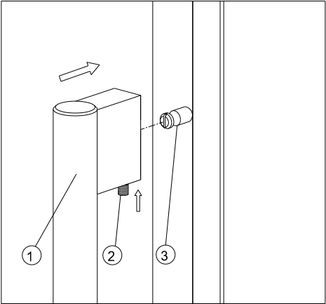
Locate the handle ○,1 over the fixing pins ○,3 of the door and using the supplied allen key, tighten the securing grub screws ○,2 to fix the handle.

DESIGN 2 –
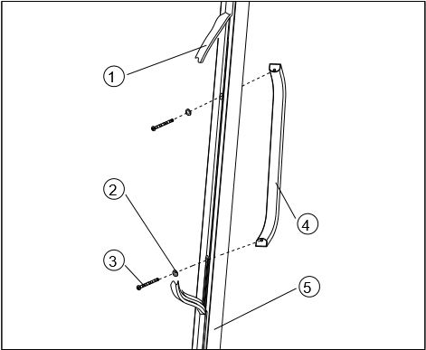

- Remove the door gasket ○,1 on the side you wish to install the handle - you can see two designated holes for handle installation.
- Install the handle ○,4 tightly as shown above with two screws ○,3 and flat washers ○,2 provided.
- Replace the door gasket.
Note: All parts removed must be saved to do the reinstallation of door.

REVERSING THE DOOR HINGE
It is possible to reverse the door on this appliance, if required.
To do so, follow the steps below:

DESIGN 1 – For built-under models
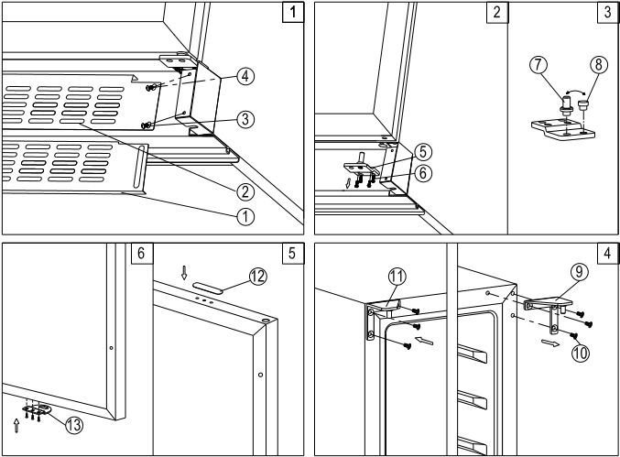
- Remove the ventilation grille ○,2 and the adjustable ventilation grille ○,1 by unscrewing the screws ○,3 & ○,4. (Fig. 1) NOTE: For some models without adjustable ventilation grille, the step is not needed.
- Remove the bottom hinge ○,5 by unscrewing the four lock screws ○,6. Be careful to hold the glass door firmly after removing the screws.
(Fig. 2)
- Gently pull down to remove the glass door from the right top hinge and place it on a padded surface to avoid the risk of damage. Then remove the right top hinge ○,9. (Fig. 4)
- Unscrew and transfer hinge pin ○,7 and/or door stopper ○,8of the bottom hinge to the opposite side. (Fig. 3)
- Pop out the cover caps on the left side of cabinet and use them to cover the screw holes on the right hand side.
- Screw the alternative left top hinge ○,11, included in the fittings, on the left hand side of cabinet. (Fig. 4)
- Unscrew and transfer the holes cover ○,12 and lock catch ○,13 to the opposite side of
glass door. (Only for models with lock on the ventilation grille) (Fig. 5)
- Rotate the door 180° (No need for models with lock on the door) and relocate the door to the designated position. Then screw the bottom hinge assembly on the left designated position and tighten it after the door is leveled.
- Transfer the handles & plugs to the opposite positions and then reassembly the ventilation grilles if need.

DESIGN 2 – For fully integrated models
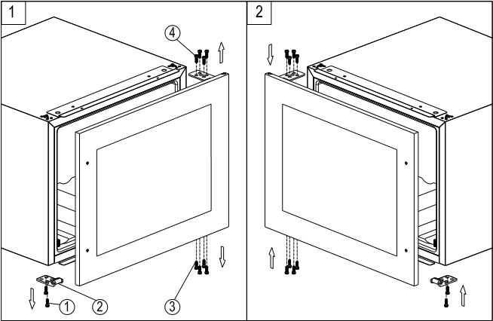
- Remove the glass door by unscrewing the eight lock screws ○,3 and ○,4. Be careful to hold the glass door firmly after removing the screws and place it on a padded surface to avoid the risk of damage.
- Unscrew and transfer the door supporter ○,2 to the opposite side.
- Rotate the glass door 180°and refit the glass door to the opposite side. Then screw and tighten it after the door is leveled.

DESIGN 3 – For tall models
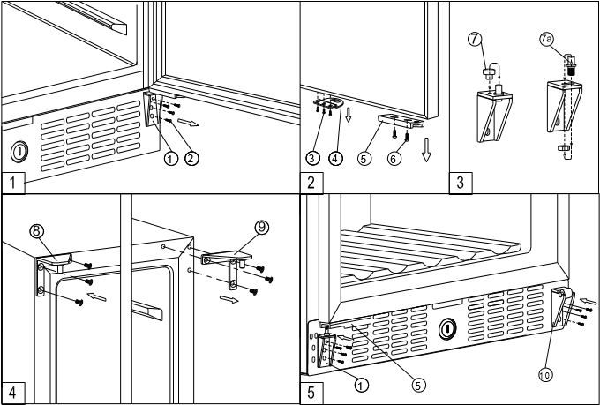
- Remove the bottom hinge ○,1 by unscrewing the four lock screws ○,2. Be careful to hold the door firmly after removing the screws.(Fig. 1)
- Gently pull down to remove the glass door from the right top hinge and place it on a padded surface to avoid the risk of damage. Then remove the right top hinge ○,9. (Fig. 4)
- Pop out the cover caps on the left side of cabinet and use them to cover the screw holes on the right hand side.
- Screw the alternative left top hinge ○,8 , included in the fittings, on the left hand side of cabinet. (Fig. 4)
- Unscrew and transfer door supporter ○,10 to the opposite side. At the same time remove the stopper pin ○,7 of bottom hinge to the opposite designated position or unscrew and transfer the hinge pin ○,7a of bottom hinge to the opposite designated position. (Fig. 5 & 3)
- Unscrew and transfer the door adapter ○,5 and lock catch ○,4 to the top designated position of glass door. (Fig. 2)
- Rotate the door 180° and relocate the glass door to the designated position. Then screw the bottom hinge on the left designated position and tighten it. (Fig. 5)
- Recheck and adjust the door alignment by loosening the screws ○,6and moving the door adapter ○,5. Tighten the screws ○,6 after the door is levelled. (Fig. 5)

OPERATING YOUR APPLIANCE
This appliance is designed for operation at certain ambient temperatures. The climate class is specified on the rating plate.
The appliance may not work properly if it is left for a long period at a temperature outside the specified range. For example, placing your unit in extreme cold or hot conditions may cause interior temperatures to fluctuate. The range between 5ºC and 20ºC (41ºF and 68ºF) may not be reached.
Climate class | Ambient room temperatures
SN  N  ST  T | +10°C to +32°C  +16°C to +32°C  +16°C to +38°C  +16°C to +43°C
NOTE: Units with no heater will not raise their internal temperature if the ambient temperature where the unit is located is lower than the set temperature.
NOTE:
- When you use the appliance for the first time or restart the appliance after having been shut off for a long time, there could be a few degrees variance between the temperature you select and the one indicated on the LED readout. This is normal and it is due to the length of the activation time. Once the unit is running for a few hours everything will be back to normal.
- If the unit is unplugged, power lost, or turned off, you must wait 3 to 5 minutes before restarting the unit. If you attempt to restart before this time delay, the unit will not start.

USE AND CONTROL
(DAU-17.58DB, DSS, DW, DAU-19.58B, SS, W; DAU-40.138B, SS; DX-94.270DBK, SDSK; DX-143.468B, SS; DX-166.428DBK, SDSK; DX-170.490TBK, STSK; DX-181.490DBK, SDSK; DX-194.490B, SSK)

CONTROL PANEL
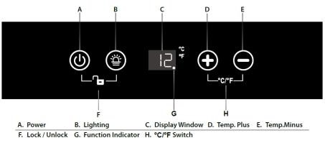
For Single Zone

For Dual Zone
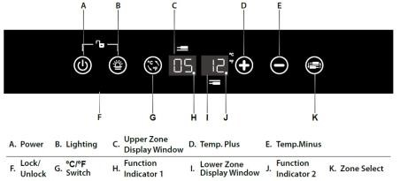

For Triple Zone
The Control Panel of upper zone is same as Single Zone above;
The Control Panel of Mid Zone and Lower Zone is same as Dual Zone above.

POWER ON/OFF CONTROL
When the appliance is plugged in to a power outlet, it powers on automatically.
Touch the power mark and hold for 10 seconds
to turn off (or turn on) the appliance.
No matter it is under a locked or unlocked condition, you can turn off the appliance by touching the power mark and holding for 10 seconds.

UNLOCKING THE CONTROL PANEL
To unlock the control panel, touch the power mark and lighting mark with 2 fingers at the same time and hold for 3 seconds . When unlocked a buzz sound will be heard. The control panel will be automatically locked with a buzz sound heard after 10 seconds without being touched. Under the locked condition, the control panel will not react to any touching order for Lighting On/Off and Temperature Setting.

INTERIOR LIGHTING ON/OFF CONTROL
Under the unlocked condition, touch the lighting mark to turn on (or turn off ) the interior cool LED lighting. The lighting will stay on until it is manually turned off.

TEMPERATURE DISPLAY WINDOW
The temperature is displayed in digital format which is the best way to be read out. The display shows the set temperature when you are setting the temperature, and it will change to be the real temperature of the inside cabinet after 10 seconds
When the temperature probe is out of order, the display will show “HH” or “LL” instead of a digital figure while continuous buzz sound will be heard. In such case the wine cooler keeps on cooling as it is considerately designed to keep periodical running of compressor and fans which helps to keep the coldness of the inside cabinet to protect your stored wines.
TEMPERATURE RANGE SETTING

For Single Zone
The default temperature setting range is E: + 5 to +20ºC (41-68 ºF).
To set a temperature range as desired, pls.make sure the control panel is under locked condition.
Press the mark for 3 seconds, the display window will flash "E"--"F"--"H"--"L" in loop with a sound of beep by every pressing. Leave the window flashing for 3 seconds. Beep sound will confirm the setting.
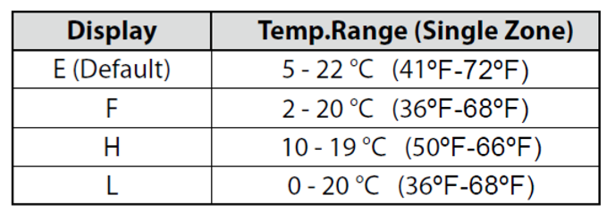

For Dual Zone
The default temperature setting ranges are E: +5 to +12 ºC (41-54 ºF) for the upper zone and +12 to +20 ºC (54-68 ºF) for the bottom zone.
To set a temperature range as desired, pls.make sure the control panel is under locked condition.
Press the mark for 3 seconds, the display windows will flash "E"--"F"--"H"--"L" in loop with a sound of beep by every pressing. Leave the display windows flashing for 3 seconds with a sound of beep to confirm the setting.
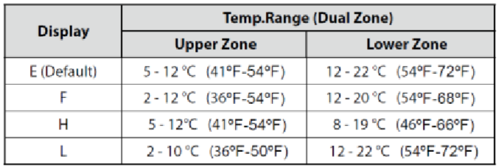

For Triple Zone
The temperature setting range of upper zone is same as Single Zone above;
The temperature setting range of Mid Zone and Lower Zone is same as Dual Zone above.
TEMPERATURE SETTING

For Single Zone
The default temperature setting range is E: +5 to +20 ºC (41-68 ºF).
Directly touch the or mark to set the wine cooler temperature as you want. The first touch on mark will recall the previous set temperature displayed. Touch the mark to increase the set temperature by 1ºC (or by 1ºF). On the contrary, touch the mark to decrease the set temperature by 1ºC (or by 1ºF).
or

For Dual Zone
The default temperature setting ranges are E: 5-12 º C (41-54 ºF) for the upper zone and 12-20 ºC (54-68 ºF) for the bottom zone.
You need to select the set zone by touching the mark before touching the or mark to set the desired temperature. The zone temperature will flash when it is ready to be set.
The first touch on mark or will recall the previous set temperature displayed in the digital window.
Touch the mark to increase the set temperature by 1ºC (or by 1ºF). On the contrary, touch the mark to decrease the set temperature by 1ºC (or by 1ºF).
WARNING!
Upper zone set temperature must be at least 3ºC cooler than lower zone set temperature!

For Triple Zone
The temperature setting of upper zone is same as Single Zone above;
The temperature setting of Mid Zone and Lower Zone is same as Dual Zone above.
Note:
For the first time to use the appliance or to restart the appliance after having been shut off for a long time, you may find a few degrees variance between the set temperature and the displayed temperature. It will be normal after a few hours running.
WARNING!
Middle zone set temperature must be at least 5º C lower than upper and lower zone set temperature mut be higher than upper zone
SELECTING FAHRENHEIT(ºF) & CELSIUS (ºC) DISPLAY

For Single Zone
Touch the marks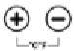 with 2 fingers at the same time and hold for 5 seconds, you can interchange the Fahrenheit and Celsius display.

For Dual Zone
Directly touch the mark , you can interchange the Fahrenheit and Celsius display for both zones at the same time.

For Triple Zone
The ºC / ºF shifting of upper zone is same as Single
Zone above. The ºC / ºF shifting of Mid Zone and Lower Zone is same as Dual Zone above.

SILENT MODE
The appliance can be set to Silent Mode, which will slow down the fans speed when the inside temperature reaches the temperature set.
The Silent Mode is set as "ON" by default, to turn off it, when the control panel is under locked condition, press and hold the light mark for 3 seconds, the icon ºC or ºF will stay on to indicate the Silent Mode is off.
To turn on Silent Mode again, when the control panel is under locked condition, press and hold the light mark for 3 seconds, the icon ºC or ºF will flash every 2 seconds continuously to indicate the Silent Mode is working.

FUNCTION INDICATING LIGHT For Single Zone
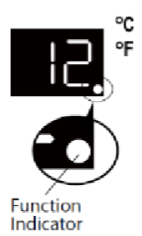
When indicator is on, compressor works.

For Dual Zone
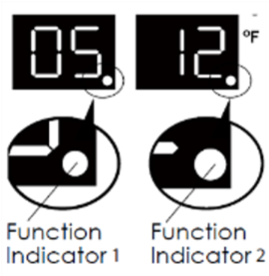
The Indicator 1 will flash every 2 seconds when the unit is plugged in.
The Indicator 1 will stay on when the compressor starts to work.
The Indicator 2 will flash every 3 seconds when the heating function of lower zone starts to work. The Indicator 2 will stay on when the cooling. function of lower zone starts to work.

GENERAL INFORMATION

Operating Noises
The unit is cooled by a compressor (refrigeration aggregate). The compressor pumps coolant through the cooling system, producing operating noise. Even when the compressor cuts out, noises caused by changes in temperature and pressure are unavoidable. Operating noise will be most audible immediately after the compressor cuts in. It becomes quieter as the operating period continues.
The following noises are normal and occur from time to time:
- Gurgling sound, caused by the refrigerant flowing through the appliance’s coils,
- Humming noise made by the motor compressor.This noise can get louder for brief periods when the motor is switching on.
- Cracking/popping sounds, resulting from the materials contraction and expansion due to temperature variations,
- Fan operating sound, to circulate the air within the wine cabinet.
Unusual noise is normally the result of improper installation. Under no circumstances must tubing come into contact with a wall, other furniture or with other tubing.
Where the unit is installed in open-plan kitchen or in partition walls, the level of operating noise will be heard more acutely. However, this is due to the surrounding architecture and not to the unit.
An individual’s perception of noise is directly linked to the environment in which the unit is located, as well the specific type of models. Our appliances are in line with international standards for such appliance and in line with the latest technical developments. But please remember that the noise of the compressor and the coolant circulating in the system is unavoidable.

DEFROSTING / HYGROMETRY / VENTILATION
Your unit is designed with an automatic defrost system. During the “Off-cycle” the evaporator behind the rear wall of the unit defrosts automatically. The condensate collects in the drain trough behind the rear wall of the unit, and part of it flows through the drainage hole into the drip tray by/above the compressor. The heat is transferred from the discharge pipe or compressor and evaporates any condensation that has collected in the tray. Part of the remaining water is collected within the unit for humidity purposes.
This system enables the creation of the correct humidity level inside your unit required by the natural cork to maintain a long lasting seal.
The appliance is not totally sealed: fresh air admission is permitted through the drainpipe. Air is circulated through the unit by means of a fan / fans and the hollow shelves.
NOTE: Frost may be accumulated on the evaporator if the unit is repeatedly opened in a high heat or high humidity location. If this frost pattern does not clear within 24 hours, your unit will require manual defrosting.

CARE AND MAINTENANCE
WARNING: Failure to unplug the appliance during service and cleaning could result in electrical shock or other personal injury.
REMOVING SHELVES
((DAU-17.58DB, DSS, DW, DAU-19.58B)

To remove any of the shelves from the rail compartment, move the shelf to the position where the notch of wooden shelf is exactly under the plastic post and then lift it up and pull out.
In order to replace the shelf, repeat steps described above in reverse. And make sure to engage the shelves with the small pegs of the extended rails when the model is equipped with roller system.

REMOVING SHELVES

(DAU-40.138B, SS; DX-94.270DBK, SDSK; DX-166.428DBK, SDSK; DX-170.490TBK, STSK; DX-181.490DBK, SDSK; DX-194.490B, SSK)
Pull out the shelf. Lift the wooden part and remove from the rails.
HUMIDITY CONTROL
The appliance is equipped with a system for maintaining the correct level of humidity. Under extremely dry environmental conditions, you may have to add some water into the humidity box provided with your wine cellar.
Fill the small plastic reservoir (humidity box) ¾ full with water, and fit onto the runners found on the top shelf of the appliance. Check the water level regularly and refill as necessary.
Please ensure the reservoir is positioned correctly on the runners on the top shelf to avoid the possibility of water spillage.

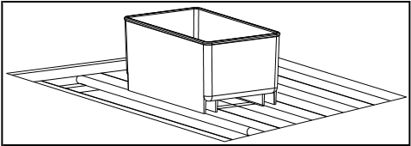

ACTIVE CHARCOAL AIR FILTER
The active charcoal air filter (if your model supplied with it) is located in the back of compartment. Replace it with a new one once a year. It can be purchased from your dealer or from the Spare Parts Department. • Remove the shelf in front of the filter.
- Grip the filter and turn it 90°clockwise or anticlockwise to remove.
- Insert the new filter in the vertical position and turn it 90° clockwise or anti-clockwise until it clicks into position.

DOOR LOCK
If the unit is provided with a lock system, the keys are located inside the plastic bag that contains the Owner’s Manual. Insert the key into the lock, push in and turn it counterclockwise to unlock the door. To lock the door do the reverse operation making sure metal pin is engaged completely. Remove the key and place it in a secure place for safekeeping.

CLEANING YOUR APPLIANCE
Turn off the power, unplug the appliance, and remove all items including shelves and rack.
Wash the inside surfaces with a warm water and baking soda solution. The solution should be about 2 tablespoons of baking soda to a pint of water.
Wash the shelves with a mild detergent solution.
Wring excess water out of the sponge or cloth when cleaning any area of the controls.
Wash the outside cabinet with warm water and mild liquid detergent. Rinse well and wipe dry with a clean soft cloth.
Do not clean the stainless steel with steel wool pads. Suggest to using an all-in-one stainless steel cleaner to clean the stainless steel and always clean in the direction of grain.

POWER FAILURE
In the event of a power interruption, all previous temperature settings are automatically memorized. If power is interrupted (power surge, breaker switch, etc.) and then powered up again, the unit will operate with the last temperature set-point.
Most power failures are corrected within a few hours and should not affect the temperature of your appliance if you minimize the number of times the door is opened. If the power is going to be off for a longer period of time, you need to take the proper steps to protect your contents.
NOTE: Irrespective of the cause, if you notice either abnormal temperature or humidity levels inside your unit, be reassured that only long and frequent exposure to these abnormal conditions can cause a detrimental effect on your wines.

VACATION TIME
Short holidays: Leave the unit in operation for holidays of less than three weeks.
Long absences: If the appliance will not be used for several months, remove all items, turn off the appliance and unplug. Clean and dry the interior thoroughly. To prevent odour and mold growth, leave the door open slightly: blocking it open if necessary.

MOVING YOUR APPLIANCE
Unplug the power plug from the electrical outlet.
Remove the contents from the racks and all moving parts from inside.
Raise the adjustable legs up to the base to avoid damage.
Tape the door shut and lock it if with a lock system.
Transport the wine cellar only in the upright position. Also protect the outside of the appliance with a blanket or similar item.

ENERGY SAVING TIPS
Should the unit be left empty for long periods of time, it is suggested that the appliance is unplugged, and after careful cleaning, leave the door ajar to allow air to circulate inside the cabinet in order to avoid possible condensation, mold or odors forming.
The appliance should be installed in the coolest area of the room, away from heat producing appliances, and out of the direct sunlight.
Ensure that the unit is adequately ventilated. Never cover air vents. Clean dust and dirt from the condenser at regular intervals.
Only open the door for as long as necessary and for as short a time as possible.
Store the content in an organised way.
Do not over-fill the appliance to allow air to circulate.

PROBLEMS WITH YOUR APPLIANCE
You can solve many common problems easily, saving you the cost of a possible service call.
Try the suggestions below to see if you can solve the problem before calling customer service.

TROUBLESHOOTING GUIDE (ALL MODELS)
PROBLEM | POSSIBLE CAUSE | REMEDY
Appliance does not operate. | - Appliance is not connected to a power supply.  - The appliance is turned off.  - The circuit breaker tripped or a blown fuse. | - Connect the appliance.  - Switch on the appliance.  - Switch on circuit breaker or replace fuse.
Appliance is not cold enough. | - The temperature is not set correctly.  - The ambient temperature could require a higher temperature setting.  - The door was opened too often.  - The door was not closed completely. • Door is not hermetically-sealed.  - The condenser is too dirty.  - The ventilation opening is blocked or too dusty. | - Check the set temperature. • Set a higher temperature.  - Do not open the door more often than necessary.  - Close door properly.  - Check the door seal and clean or replace.  - Clean the condenser when necessary.  - Clear the obstructions and clean the dust.
Appliance turns itself on and off frequently. | - The room temperature is higher than average.  - A large amount of bottles has been added to the unit.  - The door is open too often.  - The door is not closed completely.  - The door gasket does not seal properly. | - Put the appliance in a cooler place.  - Leave the appliance to work for a while until the set temperature has been reached.  - Do not open the door more often than necessary.  - Close door properly.  - Check the door seal and clean or replace.
The light does not work. | - Appliance is not connected to a power supply.  - The circuit breaker tripped or a blown fuse.  - The light was switched off on the control panel. | - Connect the appliance.  - Switch on circuit breaker or replace fuse.  - Switch on the light.
Vibrations. | • The appliance is not properly level. | • Level the appliance with the adjustable feet.
The appliance seems to make too much noise. | The rattling noise may come from the flow of the refrigerant, which is normal. As each cycle ends, you may hear gurgling sounds caused by the flow of refrigerant in your appliance.If temperature fluctuations occur, the contraction and expansion of the inner walls may cause popping and cracking noises.
 | • The appliance is not properly level. | • Level the appliance with the adjustable feet.
The door will not close properly. | - The appliance is not properly level.  - The door was reversed and not properly installed.  - The gasket is dirty.  - The shelves are out of position. | - Level the appliance with the adjustable feet.  - Check the door hinge and reassemble correctly.  - Clean the door gasket.  - Check the shelves and refit correctly.
Display “E0”, “E1”. “E2”, “E3”, “E4”, | • “E0” indicates the communication error for 3 zone models. | • Call for service.
“E5”, “E6” or “E7”. | - “E1” or “E2” indicates that the air temperature sensor is failed.  - “E3” or “E4” indicates that the defrost sensor in the evaporator is failed.  - “E5” indicates the defrost heater failure.  - “E6” indicates the solenoid valve failure.  - “E7” indicates the door switch failure.
The alarm sounds  and the temperature display flashes. | - Has the appliance door been open for longer than 60 seconds? If not, then the temperature has risen higher or fallen lower than the temperature that has been set. This could be due to:  - The appliance door being opened too often.  - The ventilation opening being covered or too dusty.  - A lengthy interruption to the power supply.  - A large amount of bottles has been added to the unit. | - If yes, close the door.  - Do not open the door more often than necessary.  - Clear the obstructions and clean the dust.  - Leave the appliance to work for a while until the set temperature has been reached.
The icon “--” is lit up and flashing in the temperature display. | • The display temperature is out of the range. | • Only temperatures within the range 0~99°F/-9~37°C the appliance can display will be shown. If the temperature is not within this range, the icon “--” will be displayed instead. That is normal.
The display window is shown with “HH” or “LL” instead of a digital figure, and/or with continuous buzz sound. | • The temperature probe is out of order | • Call for service.

WARRANTY
The warranty does not cover:
- Damage in transit or when moving the appliance.
- Any damages caused from negligence, accident, improper use, improper installation/service or use for purposes other than those described in the instruction manual.
- Damage caused by connecting your product to the wrong power source.
- Damage from power failure.
- Faulty installation or modification made during installation.
- Damage caused by unauthorized repair.
- Any damages resulting from force majeure, fire disaster or natural disaster.
- Alterations to the product without express permission from the manufacturer.
- Parts such as light, removable shelves, or plastic.
- Any spoilage or damage to wines or any other contents incidental or consequential to possible defects of the unit.
NOTE: The warranty clauses and specifications are subject to change without notice.

